Current Code Generation Process
The caCORE SDK system usage begins with the code generation process. The process involves following steps

- Create object model
- Create data model
- Perform object and data model mapping (manually or using caAdapter)
- Configure code generator
- Generate the system which includes the following steps
  - Compile code generator code
  - Compile JET templates
  - Execute fix-xmi task
  - Execute code generator for each artifact to be generated
    - Read XMI file
    - Generate the artifact
    - Write artifact to the file
  - Compile the framework code
  - Package the various components of the system

The artifacts produced in the 3.2 version were required to be generated for the SDK 3.2 system to function. Some of these generated artifacts were required for JDK 1.4 based system while others were required for the way system was built. The old process of codegen and its generated artifacts has following problems

- Works on only XMI file produced by Enterprise Architect
- Forces user to use the SDK generated O/R mapping file and the beans
- Takes very long time to generate the system with a big model
- Difficult to debug the problems in the code generation

New Requirements

- Support open source UML modeling tool
- Support roundtrip XMI files
- Support JDK 1.5 features like generics and enumeration in the beans
- Re-architect web services
- Support multiple concurrent users on a secured system

In order to implement these requirements, the codegen needs a complete rewrite. The rewrite has to be done as the new XMI processor which supports roundtrip XMI files is not compatible with the NetBeans MDR parser. There are two paths that can be considered for the generated artifacts

- Generate same old artifacts with the new XMI processor and do not change the runtime system
- Generate fewer artifacts and fine tune the runtime system to work with these artifacts.

Both the options mentioned above have its pros and cons. The first alternative to generate the artifacts in old fashion way will produce something which is not usable for a long time. As SDK 4.0 version will be out, we will have to maintain and support those old artifacts for at least two more years. Also, the time required to create the artifact generation code will be going towards something that is not desired. This will also restrict the SDK to move into the desired future direction.

Second alternative will require fewer artifacts as compared to the first approach. As the artifacts are changing we will have to tune the runtime system to work with the new artifacts. Time and resources required to implement the changes in the runtime system can be easily be balanced with the smaller list of artifacts to be produced. Following sections will provide more details on the design of the second alternative.

Overview of Artifacts between 3.1/3.2 and 4.0

Following table describes the artifacts as they were on SDK 3.1/3.2 and how they will change in the SDK version 4.0

Artifact | 3.1/3.2 | 4.0
POJO Beans | 
SDK Java beans |  | 
Java beans Impl classes
WS beans
WS beans Impl classes
Unit test classes (JUnits)
O/R mapping file for the Java beans (*.hbm.xml)
O/R mapping file for the Impl classes
O/R configuration file (orm1.cfg.xml)
Cache configuration file (ehcache.xml)
DAO Configuration file (DAOConfig.xml)
Domain objects list (coreBeans.properties)
Association mapping file (roleLookup.properties)
XML Schema files (XSD)
Castor mapping file
Web services deployment file (wsdl) |  | ???

Important Classes

Classes | 3.1/3.2 | 4.0
ApplicationService
ApplicationServiceImpl
ApplicationServiceBusinessImpl
ApplicationServiceProvider
ApplicationServiceProxy
ApplicationServiceServerImpl
ApplicationServiceClientImpl
ClientSession
DAO
ORMDAOImpl
ORMConnection
SecurityEnabler
SessionManager
SessionMonitor
UserSession
ServiceLocator
CSMUserService
DomainObjectsCache
SecurityInterceptor
Bean Proxy

Codegen Framework
New codegen process
- Create object model
- Create data model
- Perform object and data model mapping (manually or using caAdapter)
- Configure code generator
- Generate the system which includes the following steps
  - Read XMI file
  - Validate XMI file
  - Execute codegen once for all the artifacts to be generated
    - Generate the artifact
    - Write artifact to the file
  - Compile the framework code
  - Package the various components of the system

The new codegen process will not compile the codegen source code every time; instead, the process will use the codegen jar file being created at the time of distribution. If the user of the codegen wants to modify the codegen source code or the bean generation templates then in that case he/she will be responsible for executing proper target to build the codegen jar file before invoking into the codegen.

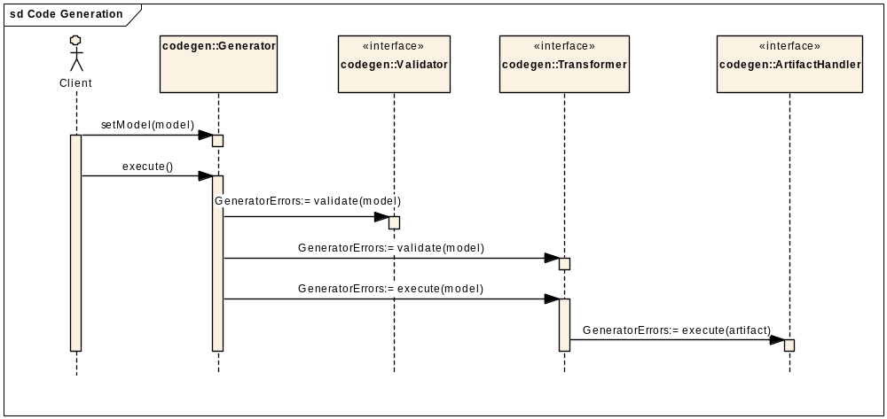

Security Framework
ACEGI Configuration
ACEGI Filters

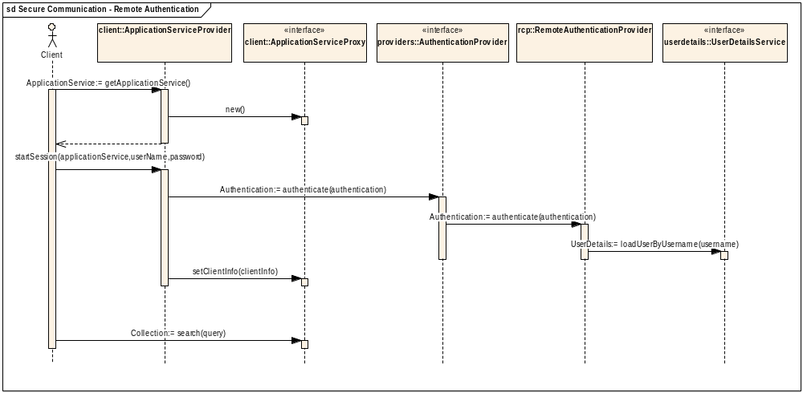
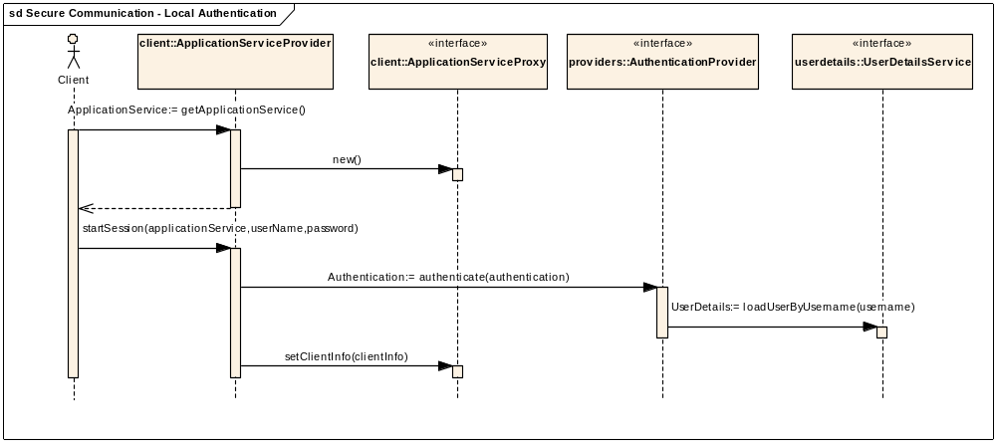

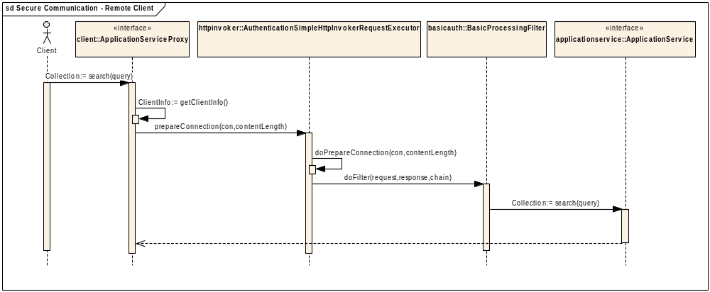

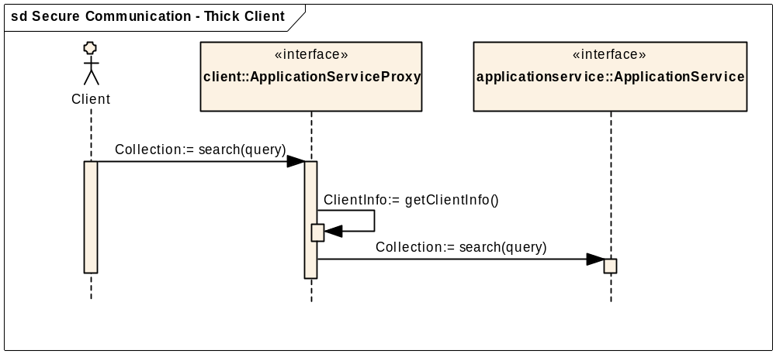

Application Service

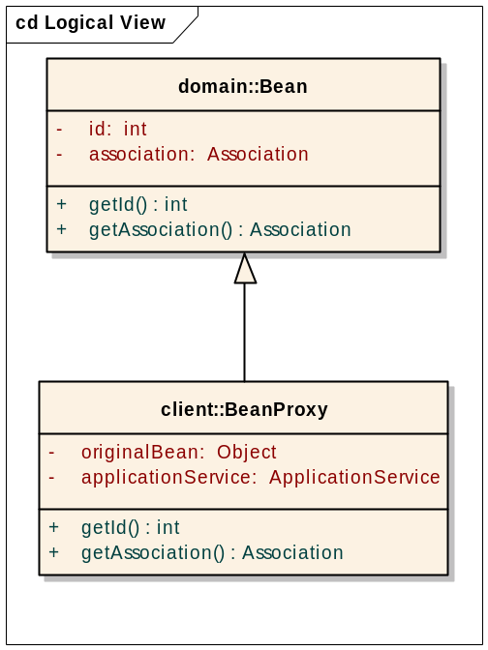

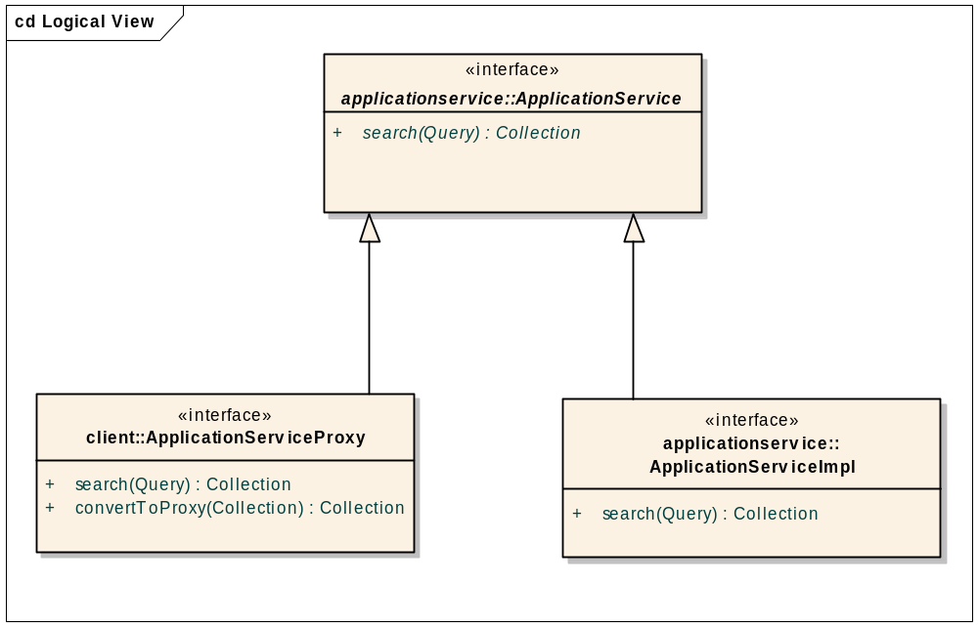

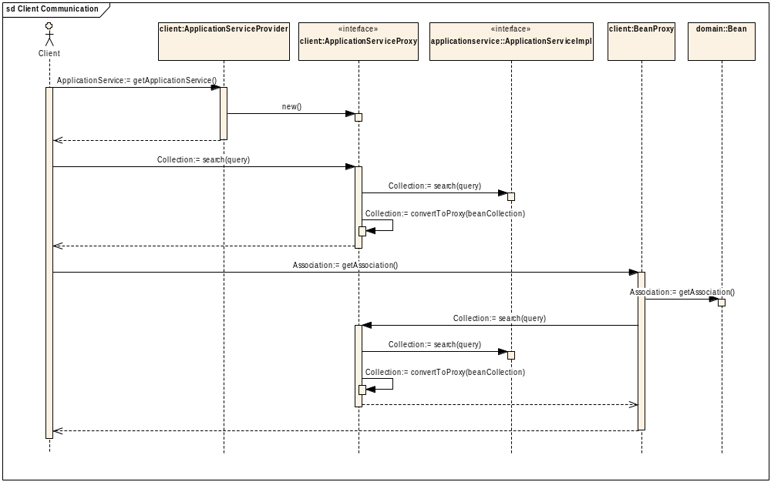

DAO
DAO, ORMDAOImpl, ORMConnection

